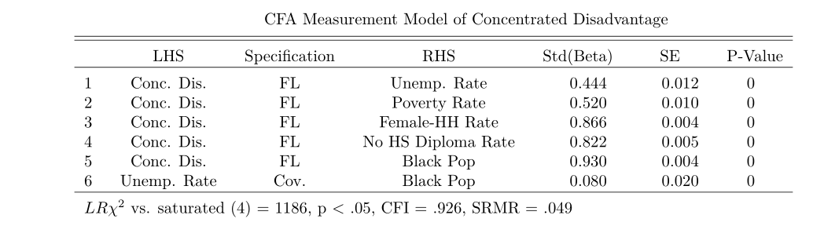

|  |  |  |  |  |
| --- | --- | --- | --- | --- |
| Appendix Table 1: Individual Distribution of Mental Health Diagnoses, Minneapolis 2016-2020 | | | | |
| Diagnoses | Clinical Classification Software Refined | Frequencya | Percentage | Weekly Rate of Hospitalization per 1,000 Residents |
| Schizophrenia spectrum and other psychotic disorders | MBD001 | 45808 | 7.5% | 0.264 |
| Depressive disorders | MBD002 | 95248 | 15.6% | 0.644 |
| Bipolar and related disorders | MBD003 | 25528 | 4.2% | 0.169 |
| Other specified and unspecified mood disorders | MBD004 | 9458 | 1.5% | 0.062 |
| Anxiety and fear-related disorders | MBD005 | 93484 | 15.3% | 0.608 |
| Obsessive-compulsive and related disorders | MBD006 | 1932 | 0.3% | 0.015 |
| Trauma- and stressor-related disorders | MBD007 | 31231 | 5.1% | 0.21 |
| Disruptive, impulse-control and conduct disorders | MBD008 | 3780 | 0.6% | 0.024 |
| Personality disorders | MBD009 | 15571 | 2.5% | 0.111 |
| Feeding and eating disorders | MBD010 | 1946 | 0.3% | 0.013 |
| Somatic disorders | MBD011 | 1367 | 0.2% | 0.009 |
| Suicidal ideation /attempt /intentional self-harm | MBD012 | 33476 | 5.5% | 0.205 |
| Miscellaneous mental and behavioral disorders/conditions | MBD013 | 4364 | 0.7% | 0.029 |
| Neurodevelopmental disorders | MBD014 | 17087 | 2.8% | 0.117 |
| Alcohol-related disorders | MBD017 | 121153 | 20.0% | 0.674 |
| Opioid-related disorders | MBD018 | 21400 | 3.5% | 0.14 |
| Cannabis-related disorders | MBD019 | 19418 | 3.2% | 0.136 |
| Sedative-related disorders | MBD020 | 2500 | 0.4% | 0.017 |
| Stimulant-related disorders | MBD021 | 29014 | 4.7% | 0.178 |
| Hallucinogen-related disorders | MBD022 | 933 | 0.2% | 0.006 |
| Inhalant-related disorders | MBD023 | 231 | 0.0% | 0.001 |
| Tobacco-related disorders | MBD024 | 340 | 0.1% | 0.003 |
| Other specified substance-related disorders | MBD025 | 23874 | 3.9% | 0.146 |
| Mental and substance use disorders in remission | MBD026 | 10259 | 1.7% | 0.068 |
| aThe total count will not sum to the sample size because there could be multiple diagnoses per individual | | |  |  |

**Depression**

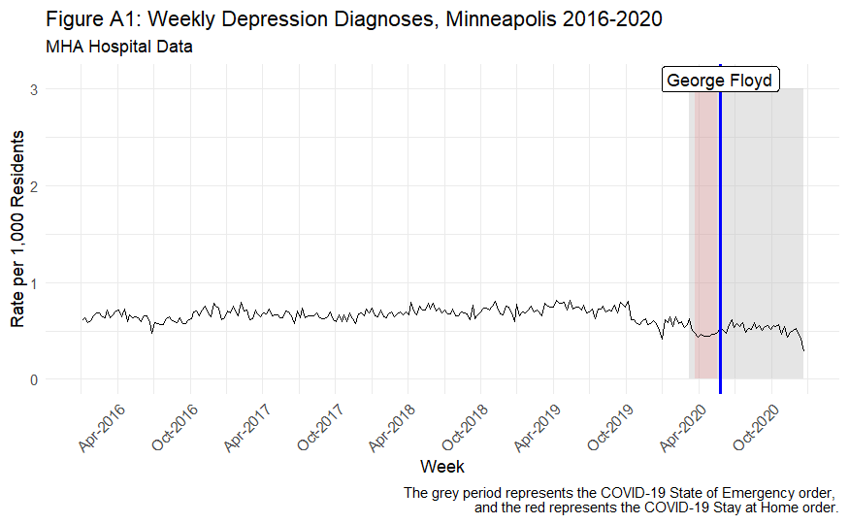

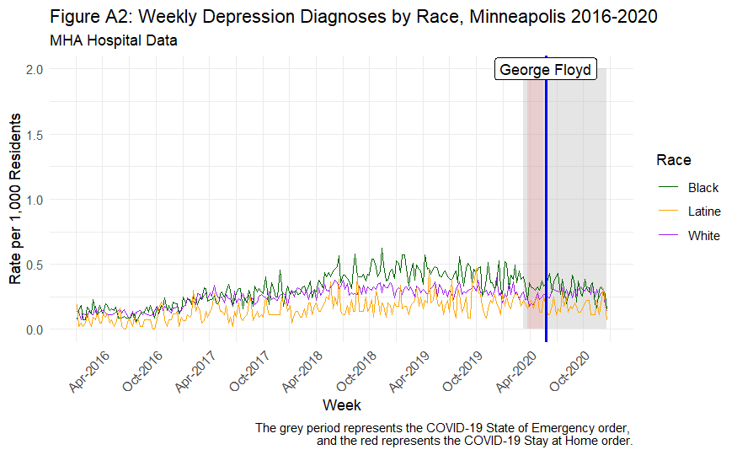

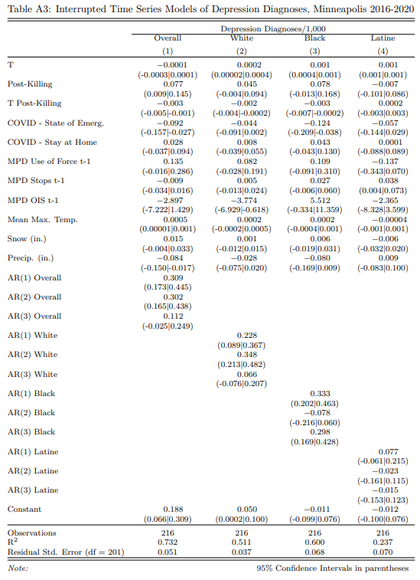

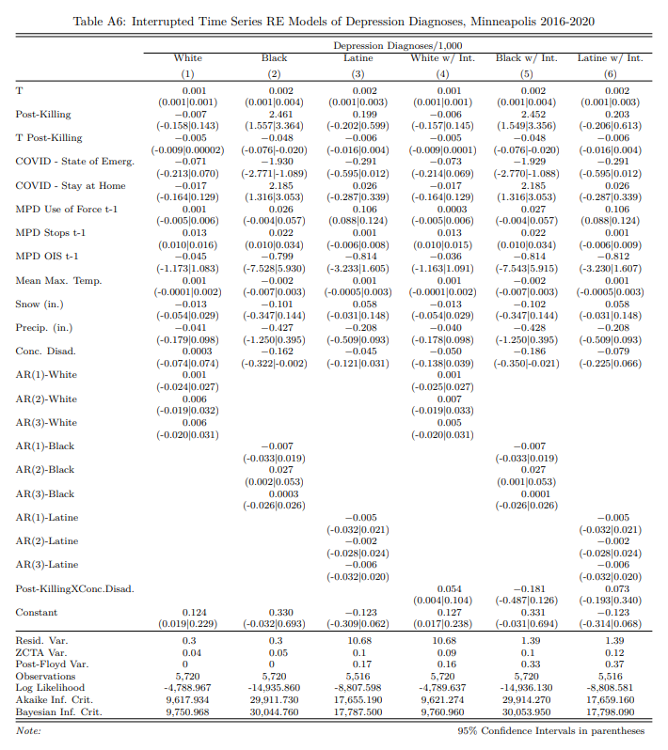

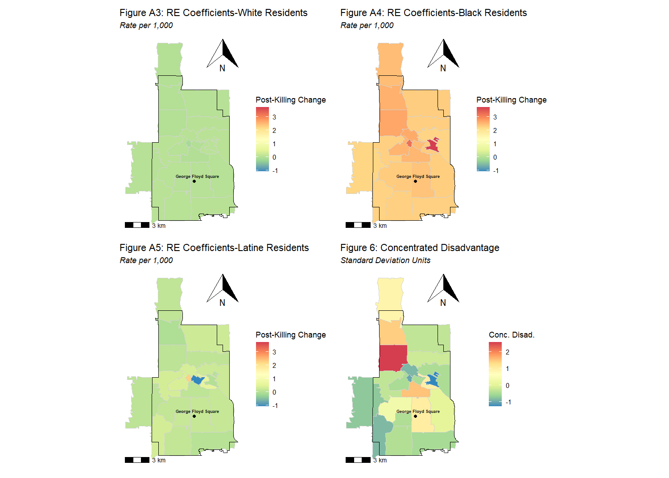

**Anxiety**

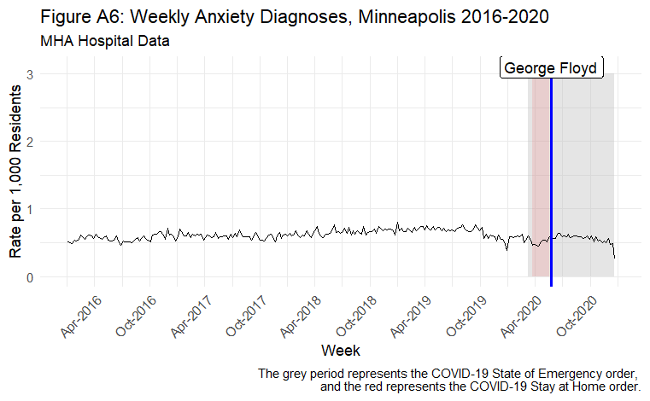

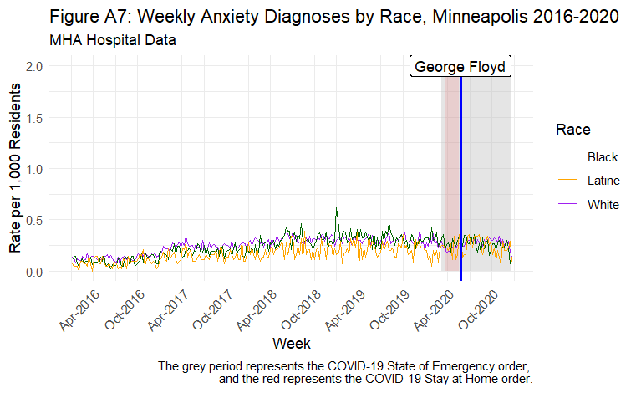

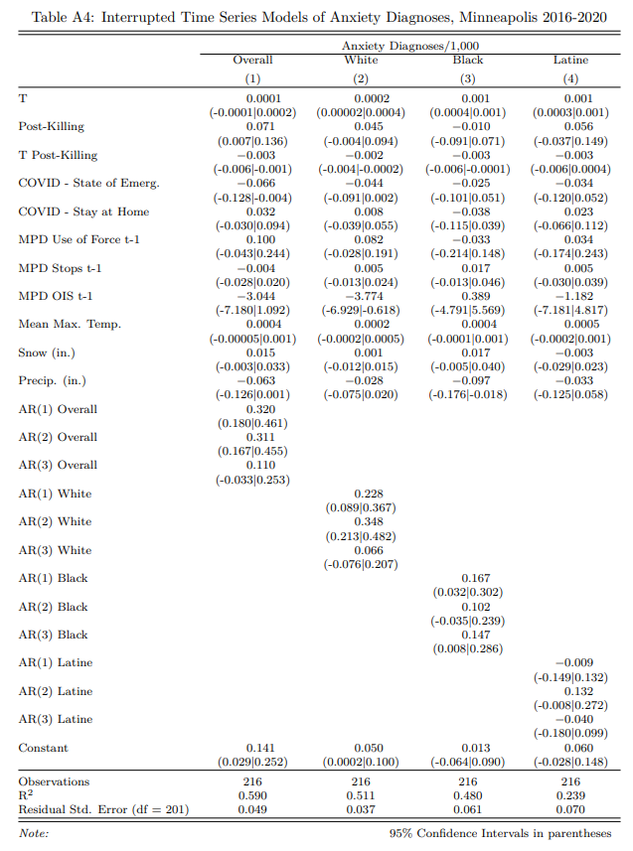

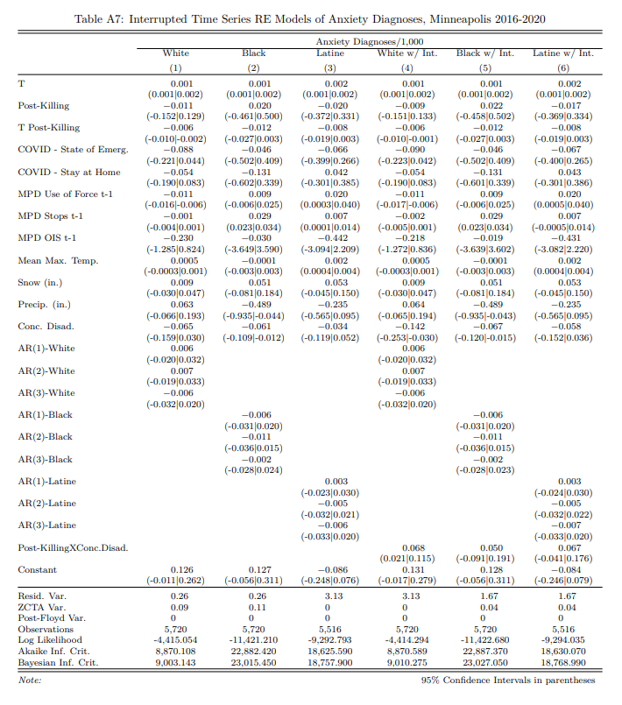

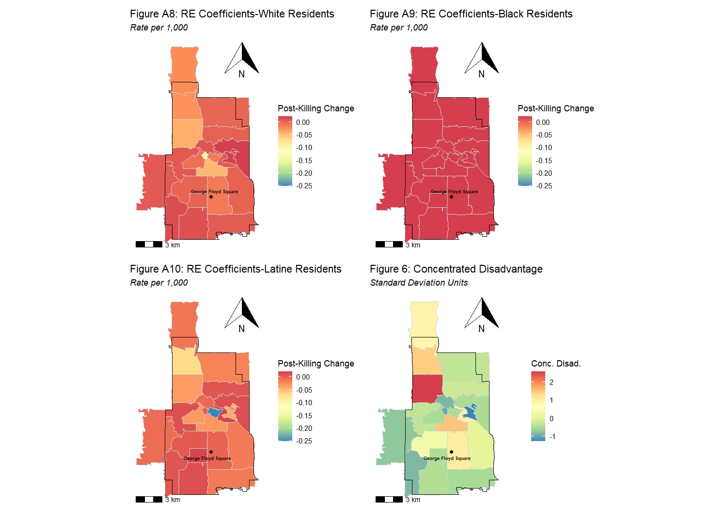

**Alcohol**

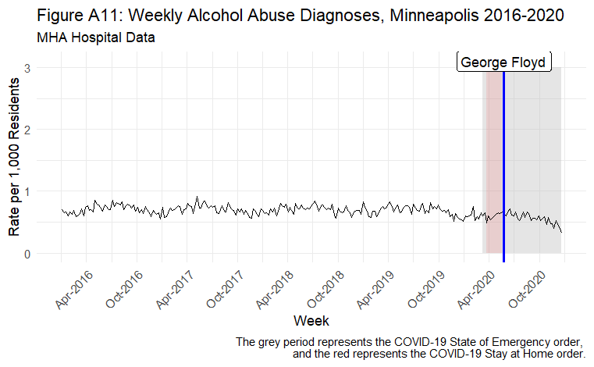

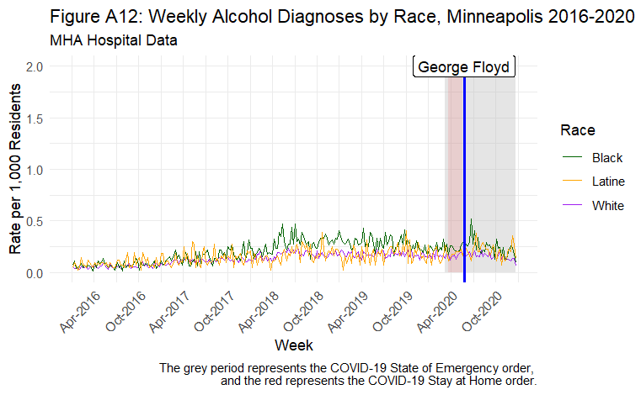

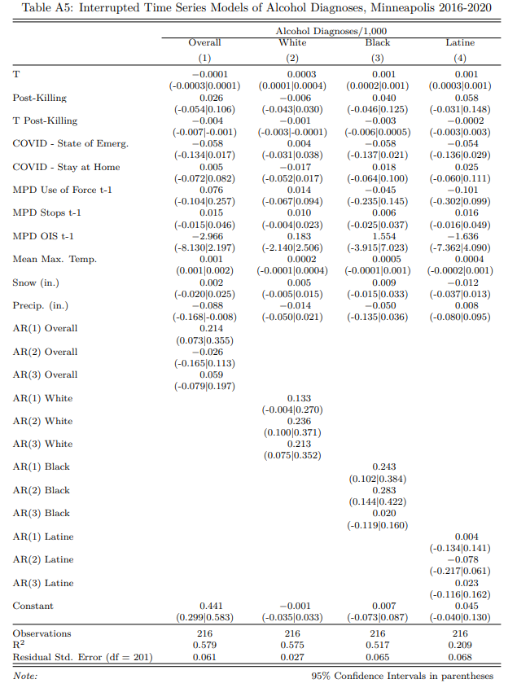

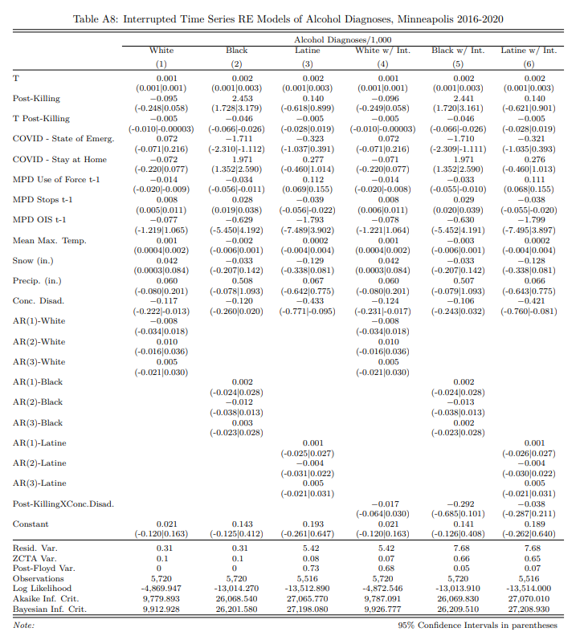

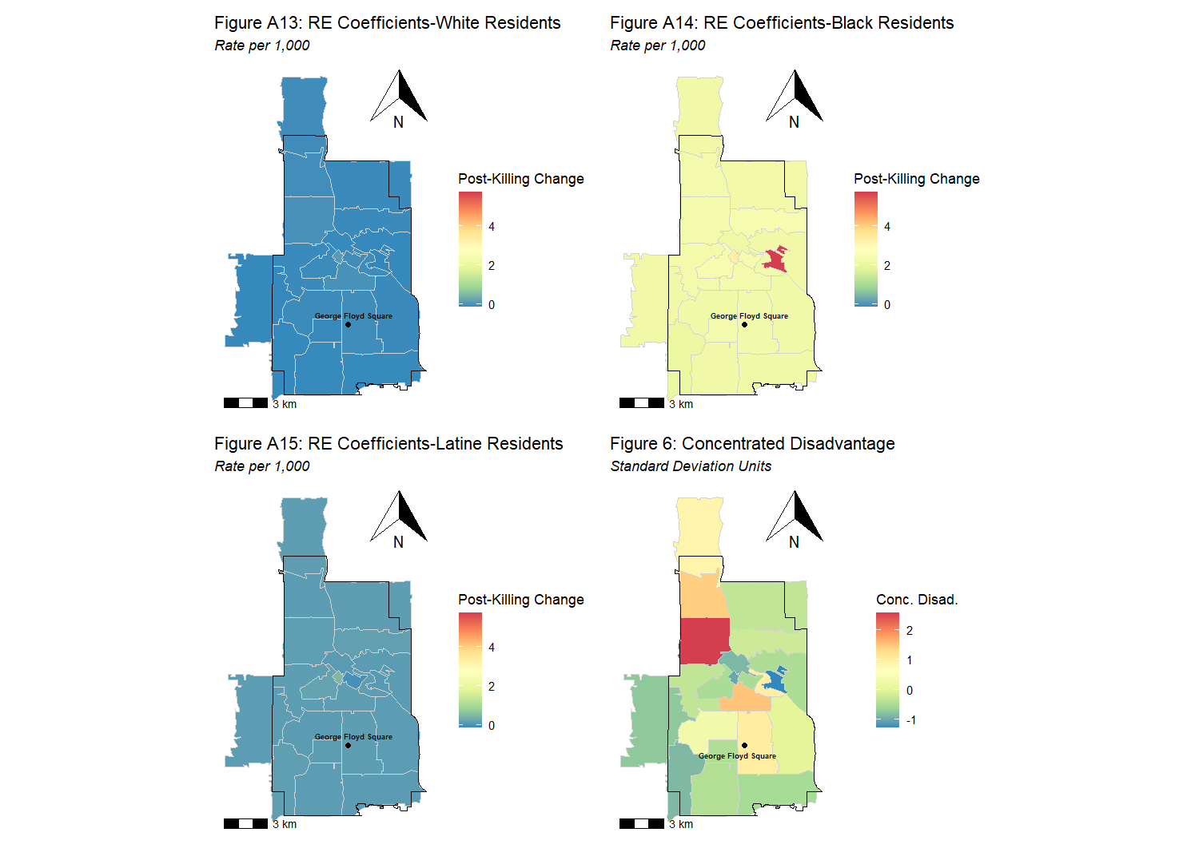

**Primary Specifications w/ Nonlinear Time Trends**

